Lab – 1

DOS Commands

1. Ping – ip

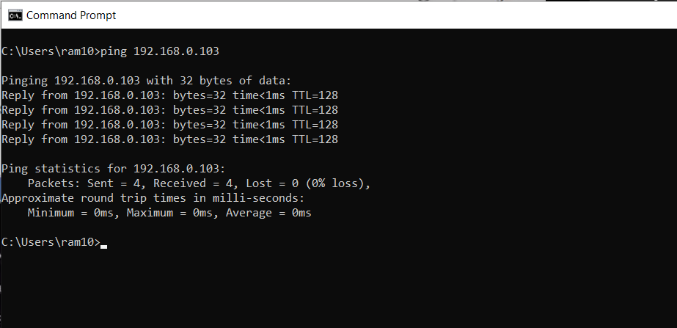

1. Ping – webpage

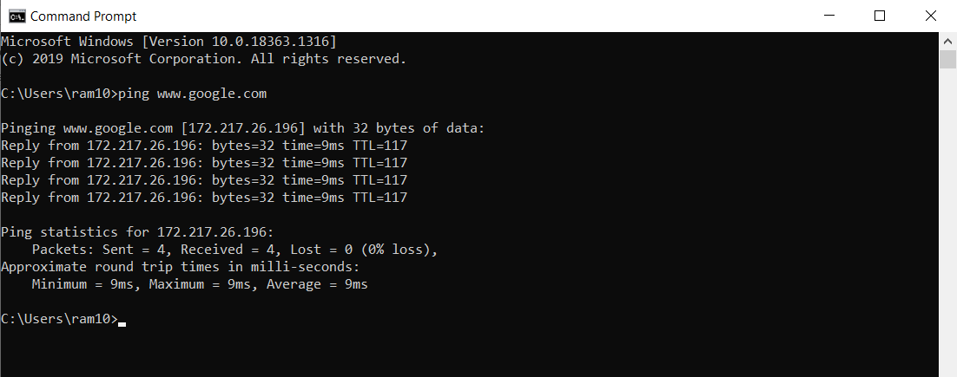

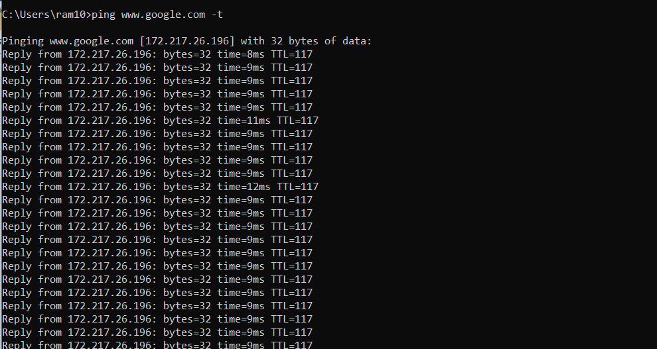

1. Ip config

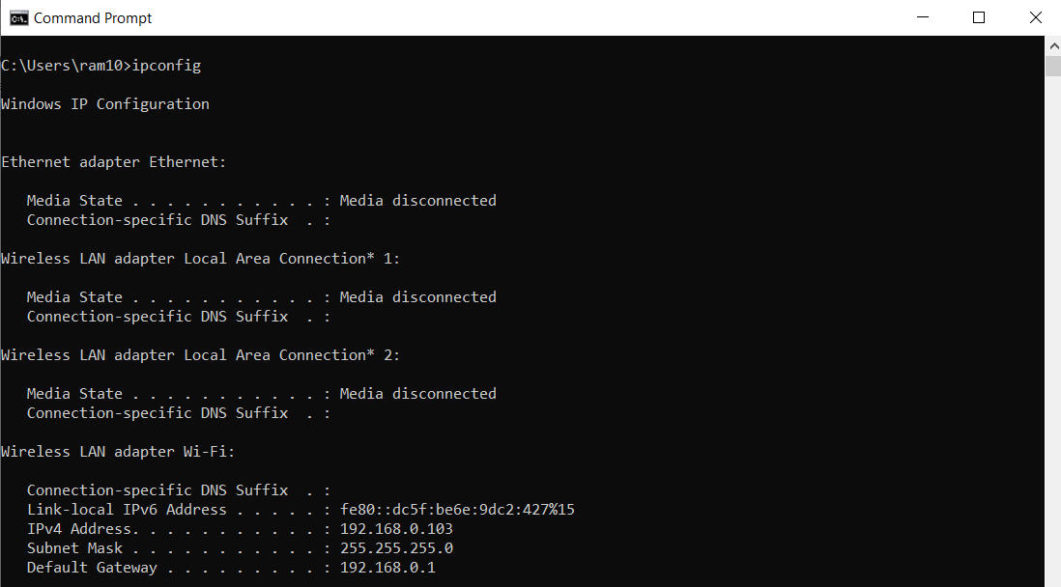

1. Ip config/all,ipconfig/release,ipconfig/renew,ipconfig/?,ipconfig/flushdns

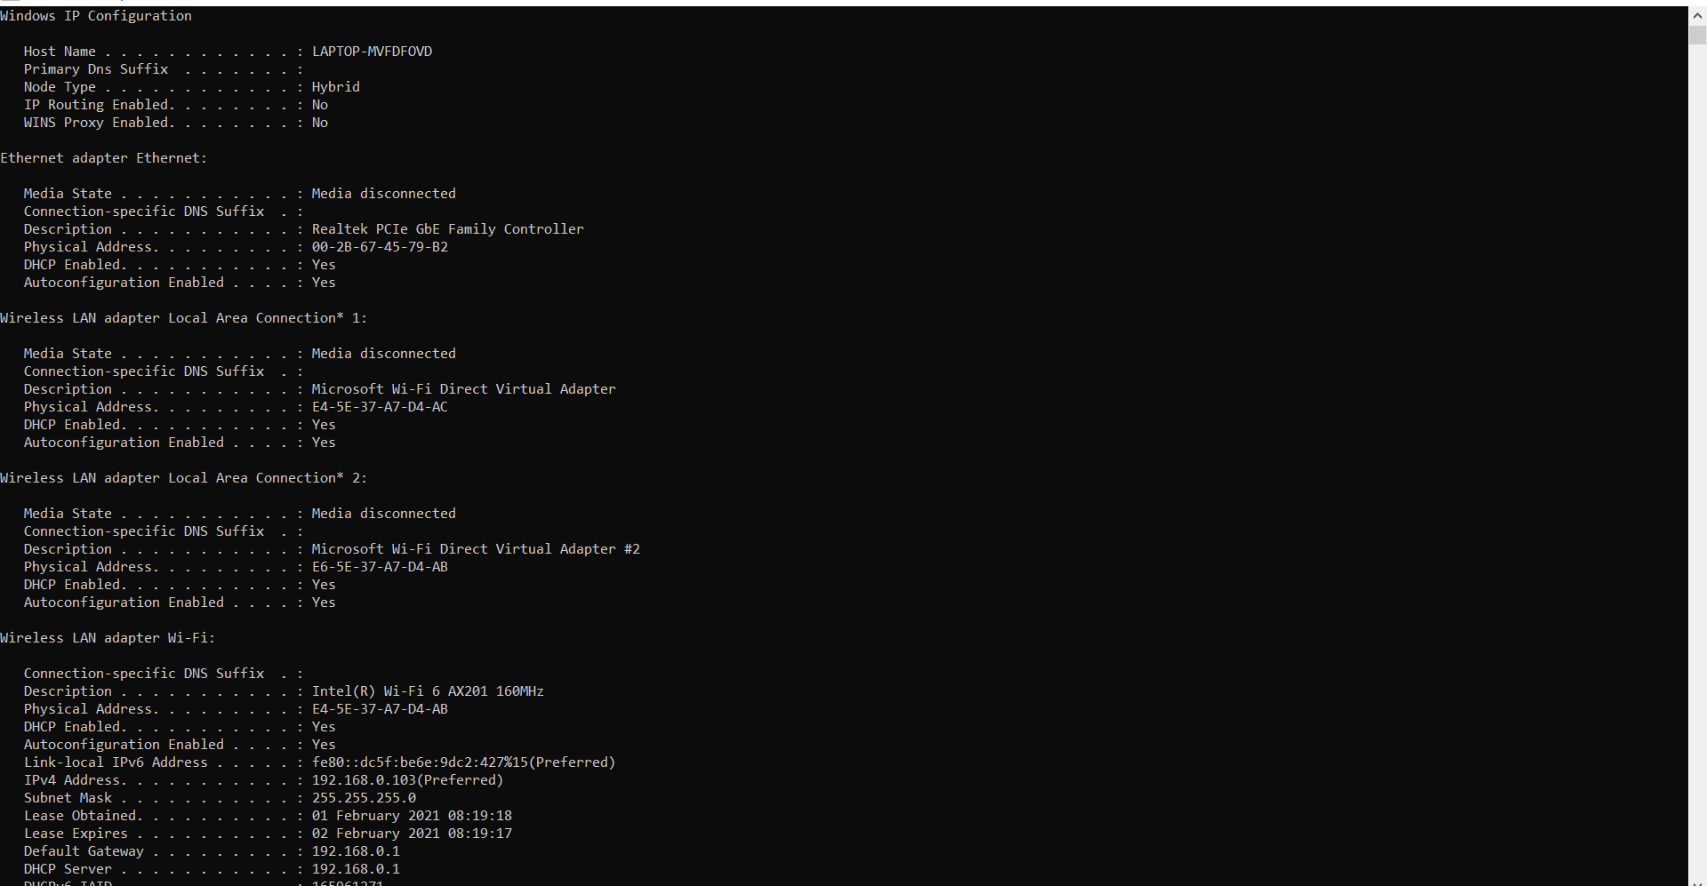

1. Tracert webpage.com

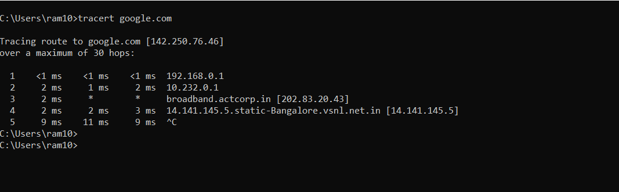

1. Netstat

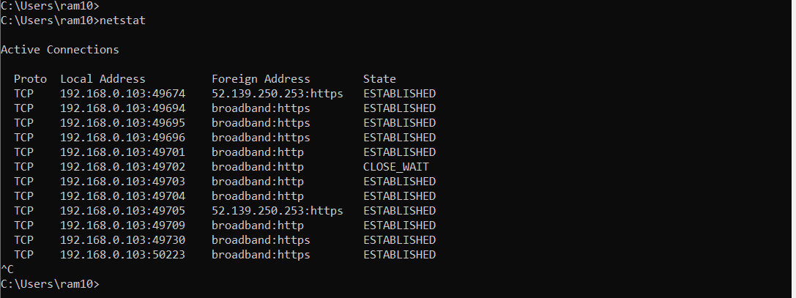

1. Netstat -n

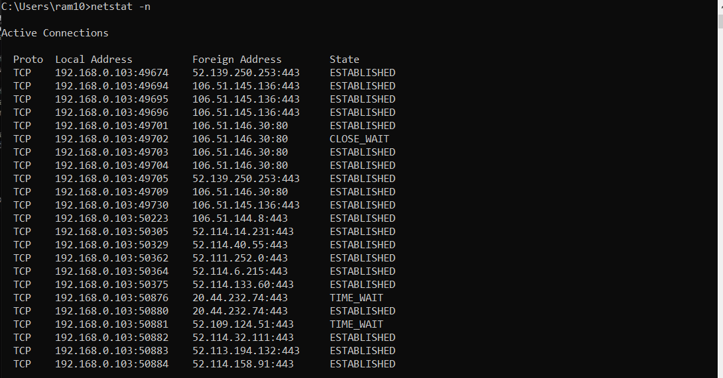

1. Netstat -an

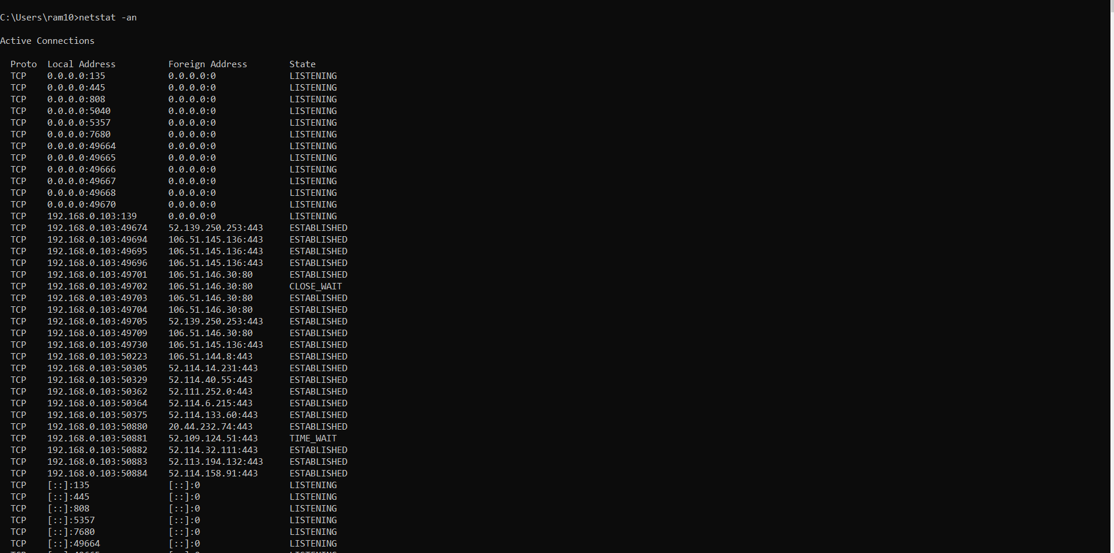

1. Arp -a

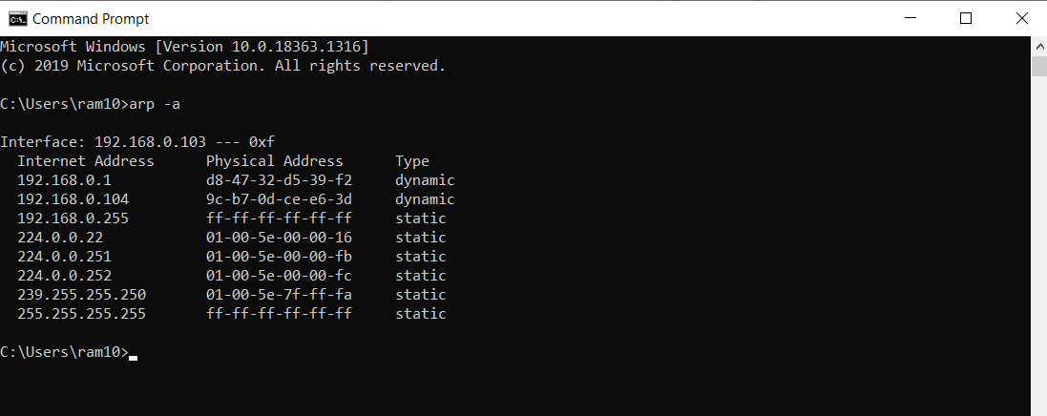

1. Arp -a ip

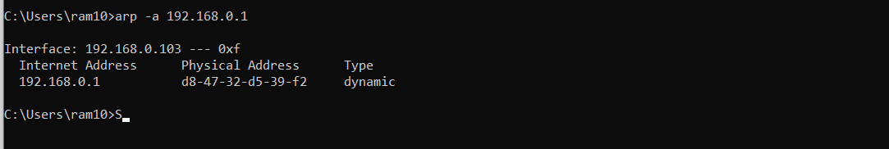

1. ping webpage -t

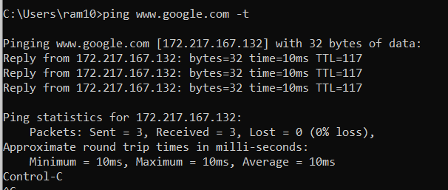

1. nbtstat -r

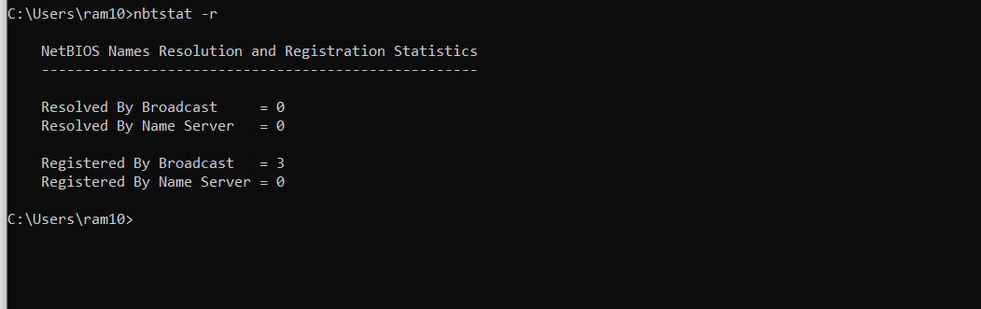

1. route -4

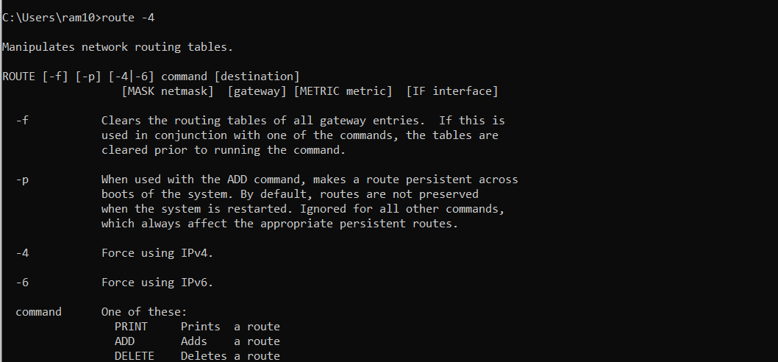

1. getmac

